**EE345L – Lab 5: Music Player and Audio Amp**

Ty Winkler and Jeremiah Bartlett

03/7/16

1. **OBJECTIVE**

1. Overview

1.1. Objectives: Why are we doing this project? What is the purpose?

The objectives of this project are to design, build and test an alarm clock. Educationally, students are learning how to design and test modular software and how to perform switch/keypad input in the background.

1.2. Process: How will the project be developed?

The project will be developed using the TM4C123 board. There will be switches or a keypad. The system will be built on a solderless breadboard and run on the usual USB power. The system may use the on board switches and/or the on board sound. Alternatively, the system may include an external keypad and/or speaker. There will be at least four hardware/software modules: switch/keypad input, time management, LCD graphics, and sound output. The process will be to design and test each module independently from the other modules. After each module is tested, the system will be built and tested.

1.3. Roles and Responsibilities: Who will do what? Who are the clients?

EE445L students are the engineers and the TA is the client. Students are expected to modify this document to clarify exactly what they plan to build. Students are allowed to divide responsibilities of the project however they wish, but, at the time of demonstration, both students are expected to understand all aspects of the design.

1.4. Interactions with Existing Systems: How will it fit in?

The system will use the TM4C123 board, a ST7735 color LCD, a solderless breadboard, and be powered using the USB cable.

1.5. Terminology: Define terms used in the document.

Power budget, device driver, critical section, latency, time jitter, and modular programming. See textbook for definitions.

1.6. Security: How will intellectual property be managed?

The system may include software from Tivaware and from the book. No software written for this project may be transmitted, viewed, or communicated with any other EE445L student past, present, or future (other than the lab partner of course). It is the responsibility of the team to keep its EE445L lab solutions secure.

2. Function Description

2.1. Functionality: What will the system do precisely?

The clock must be able to perform five functions. 1) It will display hours and minutes in both graphical and numeric forms on the LCD. The graphical output will include the 12 numbers around a circle, the hour hand, and the minute hand. The numerical output will be easy to read. 2) It will allow the operator to set the current time using switches or a keypad. 3) It will allow the operator to set the alarm time including enabling/disabling alarms. 4) It will make a sound at the alarm time. 5) It will allow the operator to stop the sound. An LED heartbeat will show when the system is running.

2.2. Scope: List the phases and what will be delivered in each phase.

Phase 1 is the preparation; phase 2 is the demonstration; and phase 3 is the lab report. Details can be found in the lab manual.

2.3. Prototypes: How will intermediate progress be demonstrated?

A prototype system running on the TM4C123 board, ST7735 color LCD, and solderless breadboard will be demonstrated. Progress will be judged by the preparation, demonstration and lab report.

2.4. Performance: Define the measures and describe how they will be determined.

The system will be judged by three qualitative measures. First, the software modules must be easy to understand and well-organized. Second, the clock display should be beautiful and effective in telling time. Third, the operation of setting the time and alarm should be simple and intuitive. The system should not have critical sections. All shared global variables must be identified with documentation that a critical section does not exist. Backward jumps in the ISR should be avoided if possible. The interrupt service routine used to maintain time must complete in as short a time as possible. This means all LCD I/O occurs in the main program. The average current on the +5V power will be measured with and without the alarm sounding.

2.5. Usability: Describe the interfaces. Be quantitative if possible.

There will be four switch inputs. In the main menu, the switches can be used to activate 1) set time; 2) set alarm; 3) turn on/off alarm; and 4) display mode. In set time and alarm modes, two switches add and subtract hours and the other two add and subtract minutes. After 10 seconds of inactivity the system reverts to the main menu. The display mode switch toggles between graphical and numeric displays. The switches will be debounced, so only one action occurs when the operator touches a switch once.

The LCD display shows the time using graphical display typical of a standard on the wall clock. The 12 numbers, the minute hand, and the hour hand are large and easy to see. The clock can also display the time in numeric mode using numbers.

The alarm sound can be a simple square wave. The sound amplitude will be just loud enough for the TA to hear when within 3 feet.

2.6. Safety: Explain any safety requirements and how they will be measured.

The alarm sound will be VERY quiet in order to respect other people in the room during testing. Connecting or disconnecting wires on the protoboard while power is applied may damage the board.

3. Deliverables

3.1. Reports: How will the system be described?

A lab report described below is due by the due date listed in the syllabus. This report includes the final requirements document.

3.2. Audits: How will the clients evaluate progress?

The preparation is due at the beginning of the lab period on the date listed in the syllabus.

3.3. Outcomes: What are the deliverables? How do we know when it is done?

There are three deliverables: preparation, demonstration, and report.

1. **ANALYSIS AND DISCUSSION**
   1. **Testing**

To test the PCB we would connect out logic analyzer to the logic analyzer pins and record the changes in voltage for different events in the system.

1. **Software & Hardware Design Solutions**
   1. **Hardware Design**

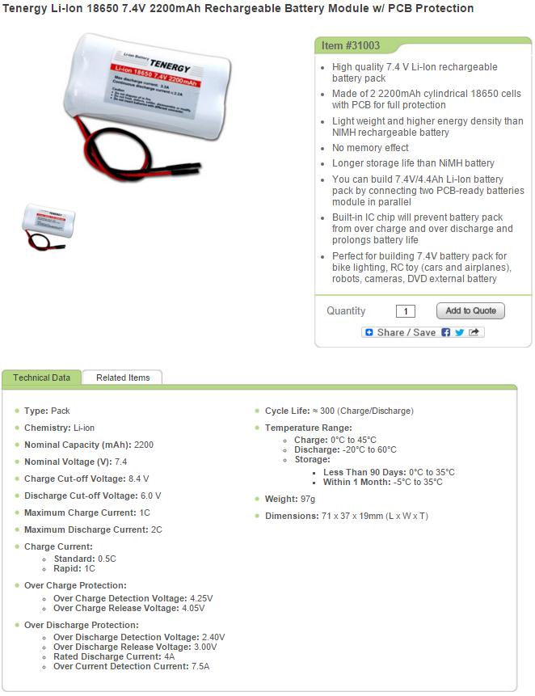

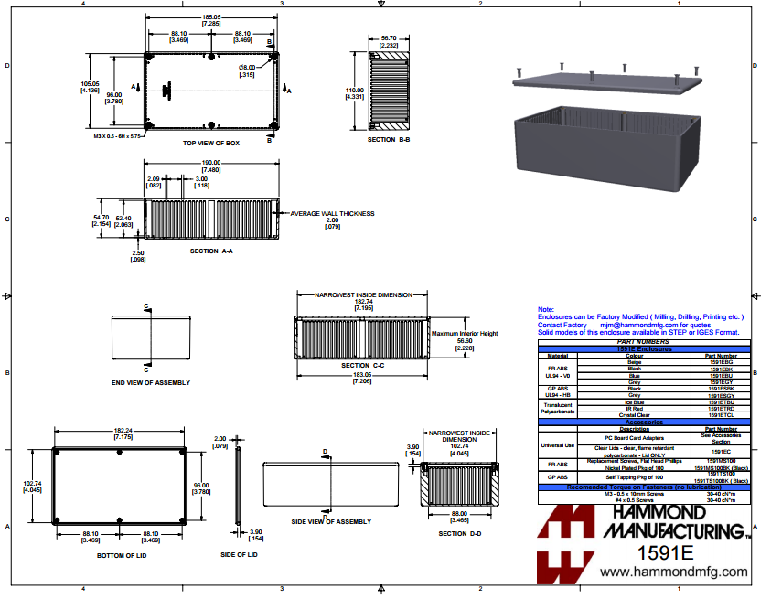

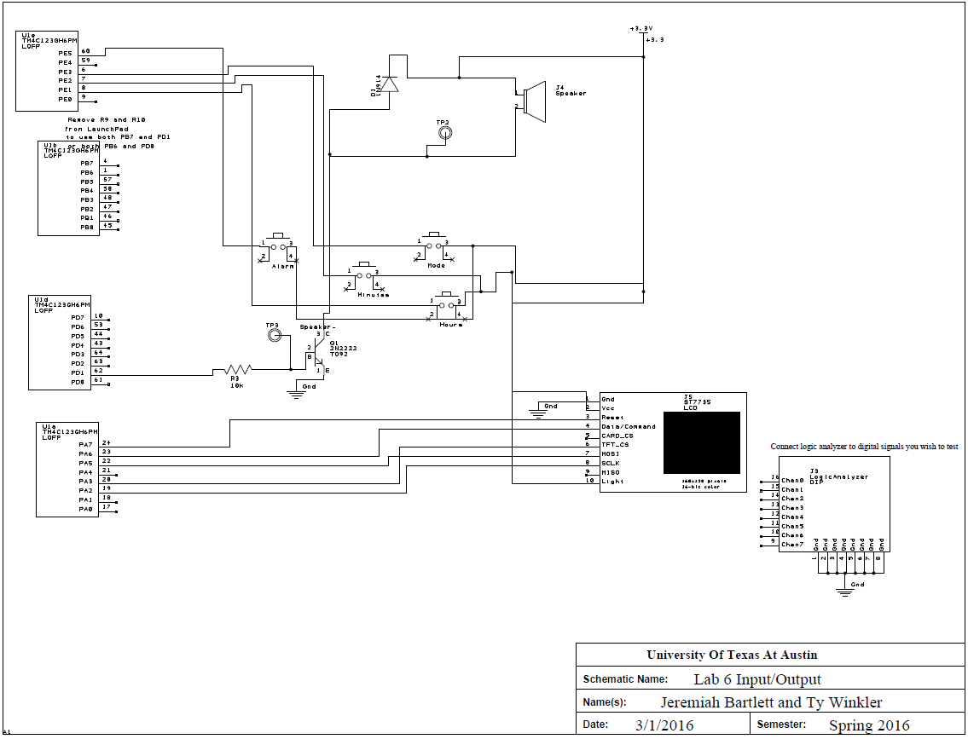

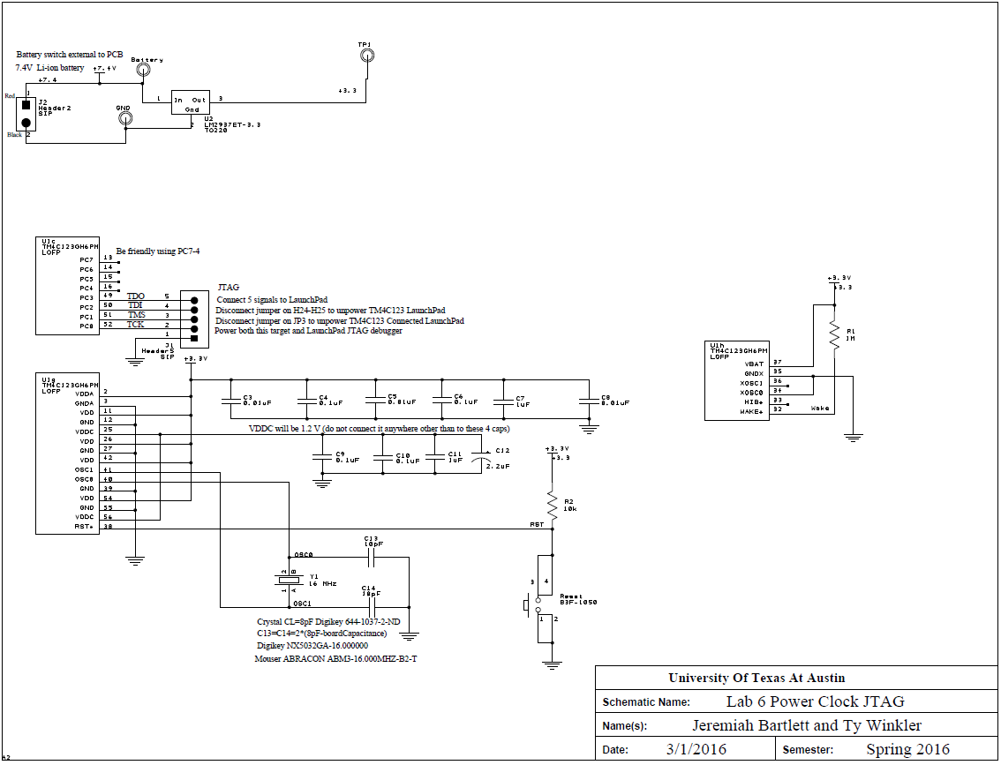

* 1. **Measurement Data**

**BOM**

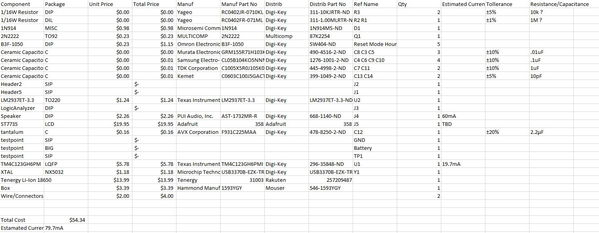

To decide on the size of the battery the amount of hours required to run was multiplied by the current draw of our system. Because our system drew 70mA of power to run the system for 25 hours would require at least a 1680mAh battery.